Name:J.HEMANTH KUMAR

Reg NO:192111700

Course code :CSA1140

Course name: OOAD

**Exp No:04**

**Exp Name: Vehical Registration Number System**

Use case Diagram

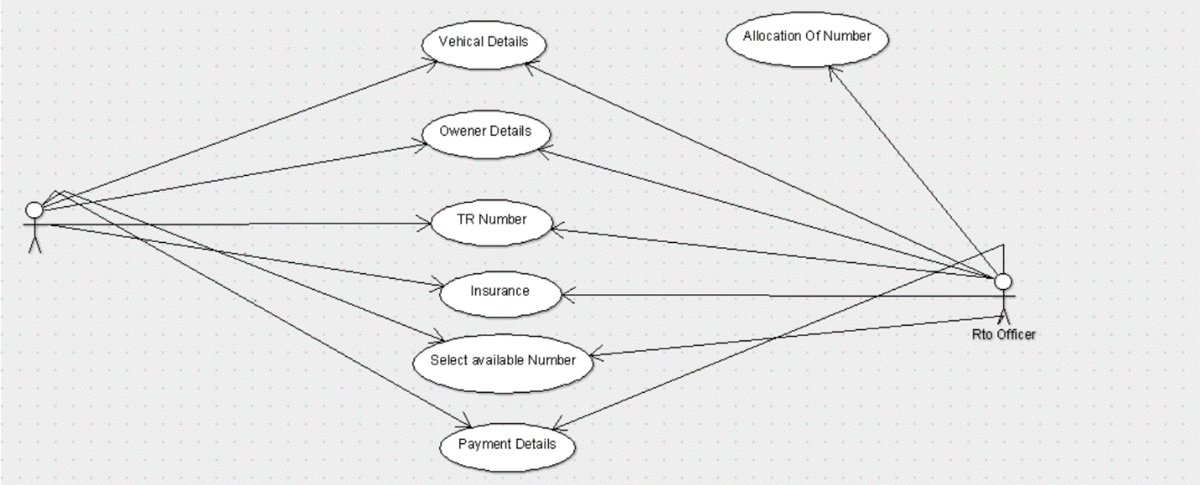

Class Diagram:

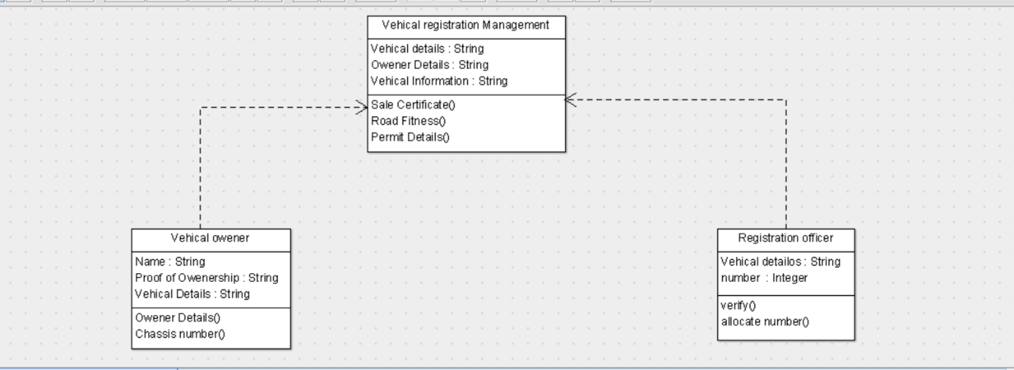

State Chart Diagram:

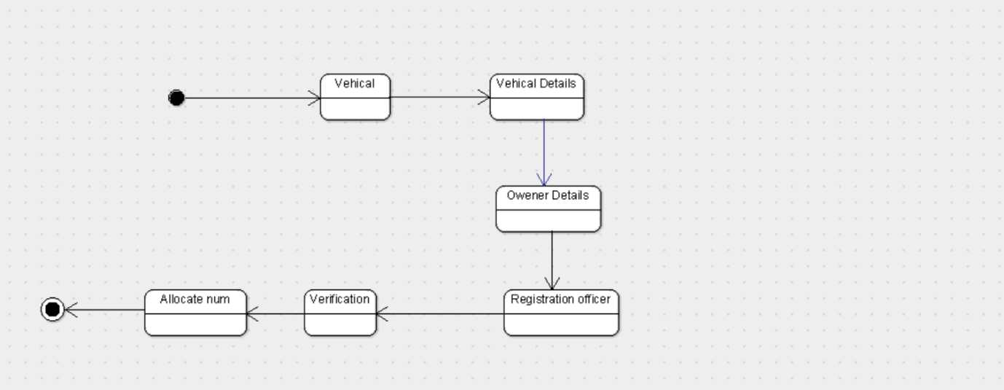

Activity Diagram:

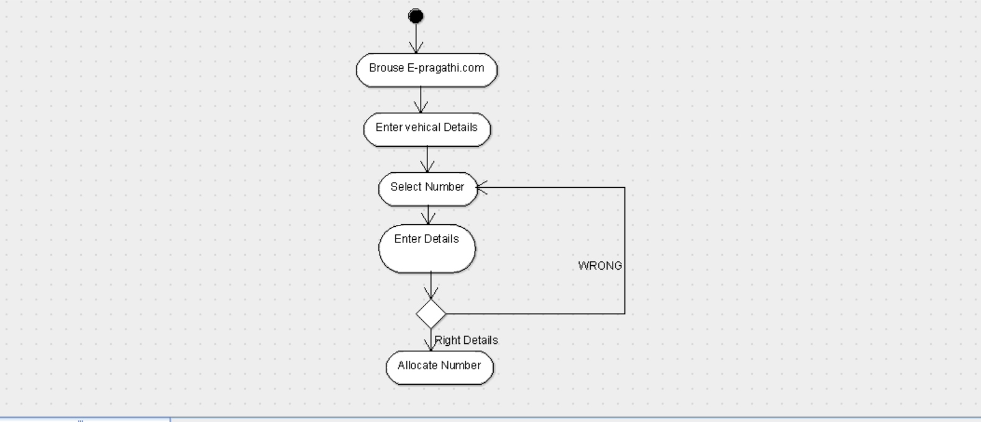

Sequence Diagram:

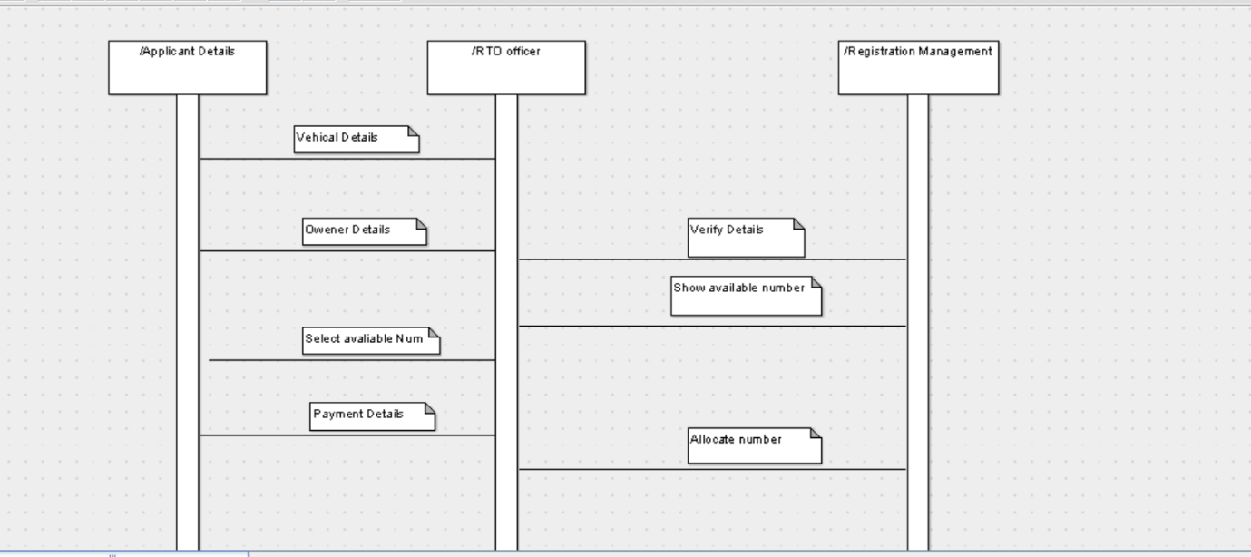

Deployment Diagram:

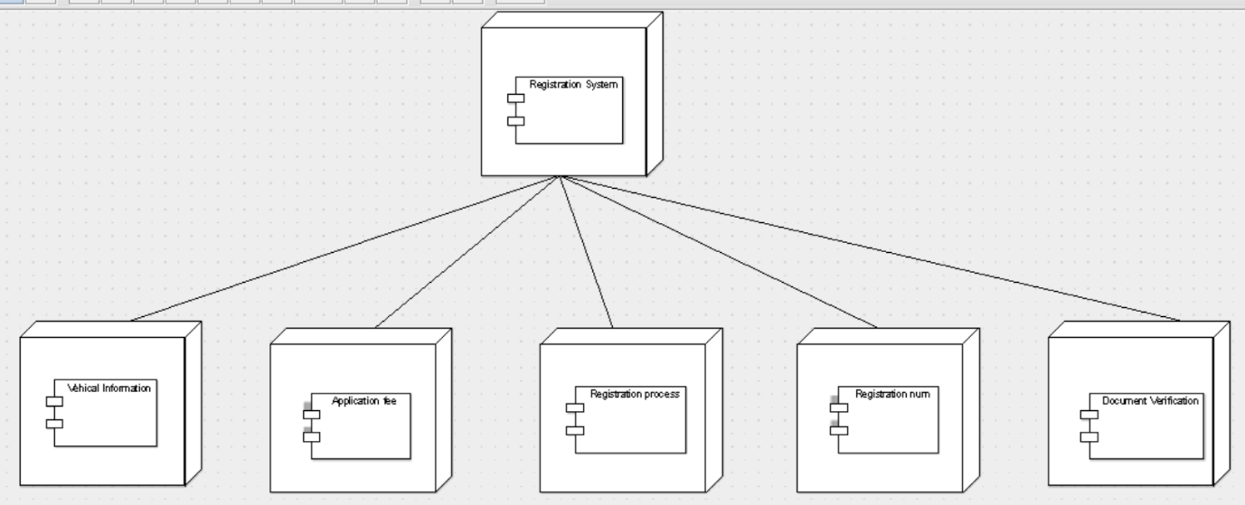

Collabration Diagram:

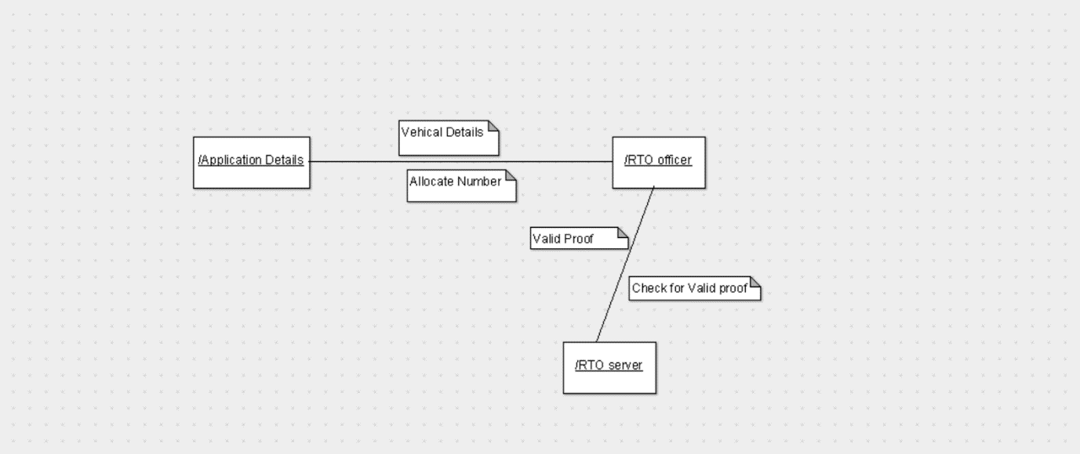

Component Diagram:

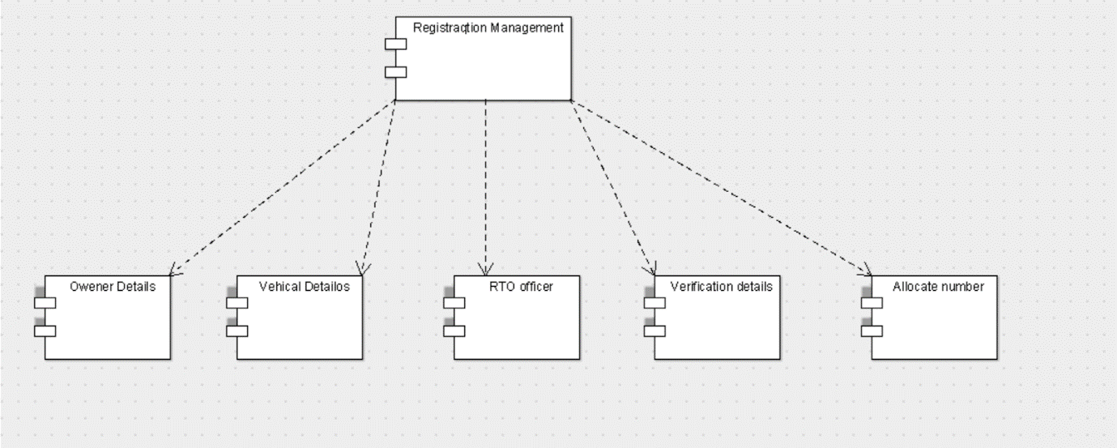

Package Diagram:

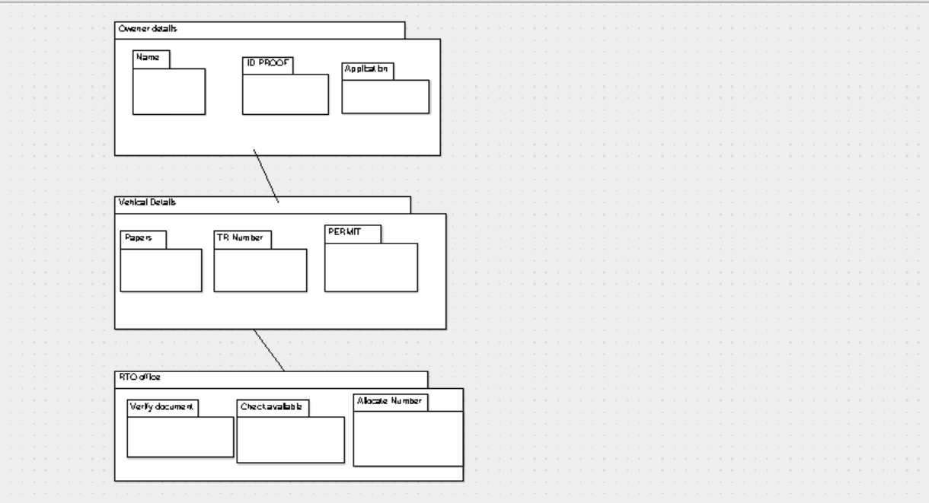

Code:

Registration office:

public class Registration officer extends Vehical registration Management {

public String Vehical detailos;

public Integer number ;

private void verify() {

}

public void allocate number() {

}

}

Vehical Owener:

public class Vehical owener {

public String Name;

public String Proof of Owenership;

public String Vehical Details

public void Owener Details() {

}

public void Chassis number() {

}

}

Vehical Registration Management:

public class Vehical registration Management {

public String Vehical details;

public String Owener Details;

public String Vehical Information;

private void Sale Certificate() {

}

public void Road Fitness() {

}

public void Permit Details() {

}

}